PCB WORKSHOP PROJECT REPORT

Project Task 1: LDR-based Light Control System

1. **Simulation process and design results.**

This section describes the simulation results of an LDR-based light control system using the UA741 operational amplifier as a comparator. The simulation was carried out on TinkerCAD, a popular online platform for simulating electronic circuits.

2. Simulation Setup

The simulation setup includes the following components:

- LDR (Light Dependent Resistor)

- Fixed Resistor (10kΩ)

- Potentiometer (10kΩ)

- UA741 Operational Amplifier

- NPN Transistor (2N2222)

- LED

- Power Supply (12V DC)

- Breadboard and connecting wires

3. **Component Connections**

- LDR and Fixed Resistor: Connected in series to form a voltage divider, with the junction connected to the non-inverting input of the UA741.

- Potentiometer: Connected across the power supply, with its wiper connected to the inverting input of the UA741 to set the reference voltage.

- UA741 Output: Connected to the base of the NPN transistor through a current-limiting resistor.

- LED: Connected in series with the collector of the NPN transistor, with its anode connected to the positive supply and the cathode to the collector.

- Power Supply: 12V DC applied across the circuit.

Circuit Diagram:

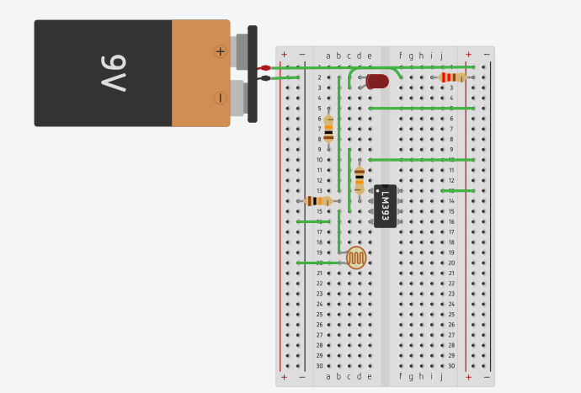

4. **Simulation Procedure**

1. Initial Configuration: Adjust the potentiometer to set the reference voltage.

2. Varying Light Intensity: Change the light intensity incident on the LDR to simulate different ambient lighting conditions.

3. Observations: Monitor the output of the comparator and the state of the LED (ON/OFF).

**5. Results and Observations**

5.1. Low Light Condition

- LDR Resistance: High resistance due to low light intensity.

- Voltage at Non-Inverting Input: Higher than the reference voltage the potentiometer sets.

- Comparator Output: High (close to Vcc, 12V).

- Transistor State: Conducting (Base current provided by the comparator output).

- LED State: ON (Current flows from collector to emitter of the transistor, through the LED).

Observation: When the ambient light is low, the voltage across the LDR increases, causing the comparator to output a high voltage, turning the transistor ON and lighting the LED.

5.2. **High Light Condition**

- LDR Resistance: Low resistance due to high light intensity.

- Voltage at Non-Inverting Input: Lower than the reference voltage set by the potentiometer.

- Comparator Output: Low (close to 0V).

- Transistor State: Not conducting (No base current).

- LED State: OFF (No current flows through the LED).

**Observation:** When the ambient light is high, the voltage across the LDR decreases, causing the comparator to output a low voltage, turning the transistor OFF and the LED remains OFF.

**5.3. Intermediate Light Condition**

- LDR Resistance: Intermediate resistance.

- Voltage at Non-Inverting Input: Approximately equal to the reference voltage.

- Comparator Output: Oscillates (depending on the exact light level and noise).

- Transistor State: May toggle or remain in a stable state depending on the hysteresis.

- LED State: May toggle or remain stable.

**2. Circuit Building on EasyEDA Tools:**

**Step 1:** Start a New Project

1. Click on "New Project" from the dashboard.

2. Name your project (e.g., "LDR Light Control System") and add a brief description.

3. Click "Create".

**Step 2:** Draw the Schematic

1. Open the Schematic Editor:

- Click on "Schematic" in the left sidebar.

- Select "New Schematic"

**Step 3. Place Components:**

- Click on the "Libraries" button or use the "E" key shortcut to open the components library.

- Search for and place the following components:

- LDR (Light Dependent Resistor): Search for "LDR" and place it on the schematic.

- Fixed Resistor (10kΩ): Search for "Resistor" and place two on the schematic.

- Potentiometer (10kΩ): Search for "Potentiometer" and place it on the schematic.

- UA741 Operational Amplifier: Search for "UA741" and place it on the schematic.

- NPN Transistor (2N2222): Search for "2N2222" and place it on the schematic.

- LED: Search for "LED" and place it on the schematic.

- Power Supply (12V DC): Use a voltage source symbol and label it as 12V DC.

- Ground: Use the ground symbol for all ground connections.

**Step 4. Connect Components:**

- Use the "Wire" tool (shortcut W) to connect the components according to the circuit diagram described earlier.

- Connect the LDR in series with a fixed resistor to form a voltage divider.

- Connect the junction of the LDR and the resistor to the non-inverting input of the UA741.

- Connect the potentiometer between the power supply and ground, with its wiper connected to the inverting input of the UA741.

- Connect the output of the UA741 to the base of the NPN transistor through a current-limiting resistor.

- Connect the LED in series with the collector of the NPN transistor, with its anode connected to the positive supply and the cathode to the collector.

- Ensure all ground connections are properly made.

**Step 5. Annotate Schematic:**

- Label each component with appropriate designators (e.g., R1, R2, LDR1, Q1, etc.).

- Use the "Text" tool to add notes or labels if necessary.

**Step 6: Perform an Electrical Rule Check (ERC)**

1. Click on "Design Manager" in the left sidebar.

2. Run the ERC to check for any electrical errors in your schematic.

3. Resolve any errors or warnings indicated by the ERC.

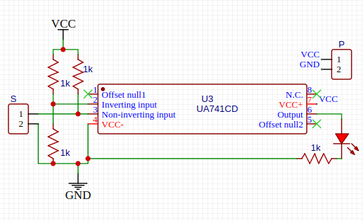

**3. PCB Designing on EasyEDA Tools:**

1. Convert Schematic to PCB:

- Click on "Convert" in the top menu and select "Schematic to PCB".

- EasyEDA will prompt you to create a PCB layout from your schematic.

2. Place Components:

- Arrange the components on the PCB layout.

- Position the components to minimize the length of the connections and optimize the layout.

3. Route Traces:

- Use the "Route" tool to connect the components with copper traces.

- Ensure power and ground traces are sufficiently thick to handle the current.

4. Add Vias and Ground Plane:

- If necessary, add vias to connect traces on different layers.

- Add a ground plane to the bottom layer for better grounding and reduced noise.

5. Design Rule Check (DRC):

- Run the DRC to check for any design rule violations.

- Fix any issues indicated by the DRC.

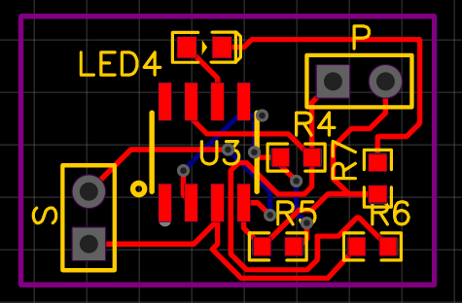

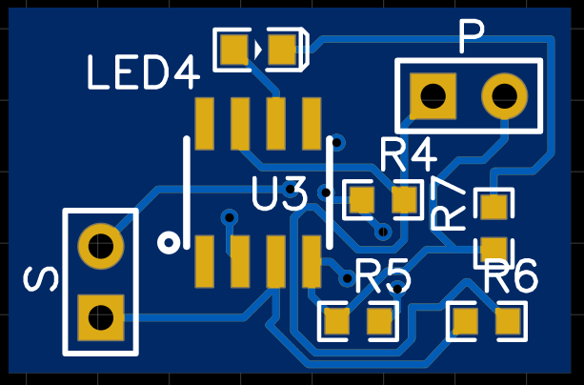

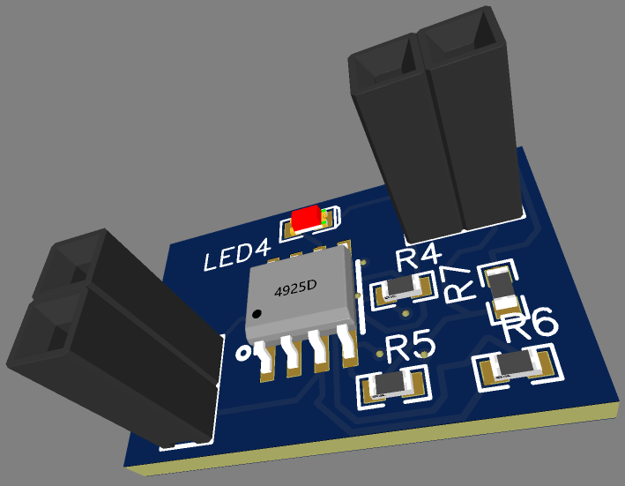

**4: Finalize and Export (Download the Gerber File)**

1. Review Layout:

- Carefully review the PCB layout to ensure all connections are correct.

- Double-check the placement of components and routing of traces.

2. Generate Gerber Files:

- Once the layout is finalised, click "Fabrication Output" in the top menu.

- Select "Generate Gerber Files".

- Follow the prompts to generate the necessary files for PCB fabrication.

3. Download Gerber Files:

- Download the generated Gerber files to your computer.

- These files can be sent to a PCB manufacturer for production

**Observation:** In intermediate lighting conditions, the system may experience instability or toggling if no hysteresis is added to the comparator circuit.

6. **Discussion**

The simulation results align with the theoretical expectations:

- Low Light: High LDR resistance results in the LED turning ON.

- High Light: Low LDR resistance results in the LED turning OFF.

- Intermediate Light: The potential for instability can be addressed by adding hysteresis (positive feedback) to the comparator circuit.

7. **Conclusion**

The LDR-based light control system effectively uses the UA741 operational amplifier as a comparator to control an LED based on ambient light levels. The simulation on TinkerCAD demonstrated the system's ability to turn the LED ON in low light and OFF in high light conditions, with some potential for instability in intermediate lighting. Adding hysteresis can mitigate this instability, resulting in a more reliable light control system.

**References**

- TinkerCAD: [https://www.tinkercad.com/](https://www.tinkercad.com/)

- UA741 Datasheet: https://www.st.com/resource/en/datasheet/ua741.pdf.

-ElectronicsTutorials:[https://www.electronics-tutorials.ws/](https://www.electronics-tutorials.ws/) for fundamental concepts on comparators, LDRs, and transistor switching.